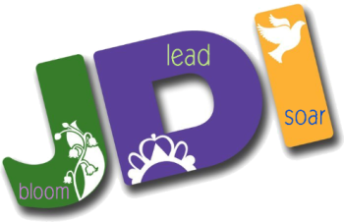

Bethel No. 86, Eureka, CA
Job's Daughters International

Lasagna Order Form

Don't feel like cooking? Got lots of out of town guests?
We are selling trays of
HOMEMADE LASAGNA (made by us!!)
(Vegetarian on request!)

1/2-sheet pan (serves approx 6-10)............................$ 32.00
1/3-sheet pan (serves approx 4-6)................................$ 22.00
---------------------------------------------------------------------------------

NAME:________________________________________________

PHONE #_______________________________________________

#__________ 1/2-sheet pan #__________ 1/3-sheet pan


Pick Up [ ] or Delivered [ ]:
[ ] December 20 (5pm-7:30pm)
[ ] December 21
Orders due December 15th
These freeze well and are great to have later!
Look for information on our dinner 12/20!

Lasagna will need to be baked for 45 minutes prior to serving.

Please call Sally Hansen 707-616-5572 or
Leia Pollard 707-845-0992 to order.

